Image classification using machine learning

A Project Report
submitted in partial fulfillment of the requirements
of
AICTE Internship on AI: Transformative Learning
with
TechSaksham – A joint CSR initiative of Microsoft & SAP

by

Ujesh Kumar Yadav, ujeshyadav007@gmail.com

Under the Guidance of
Abdul Aziz md
Master Trainer , Edunet Foundation

ACKNOWLEDGEMENT

We would like to take this opportunity to express our deep sense of gratitude to all individuals who helped us directly or indirectly during this project work.
Firstly, I would like to thank my supervisor, [Guide’s Name], for being an exceptional mentor and advisor. His advice, encouragement, and constructive feedback have been a constant source of inspiration and have significantly contributed to the successful completion of this project. His guidance throughout this internship has not only aided in overcoming technical challenges but has also helped me grow as a responsible professional.
I am also grateful to TechSaksham’s training team for providing a well-structured program and resources, which greatly facilitated my learning process. The collaborative environment fostered by the program enabled me to explore and innovate within the field of Artificial Intelligence.
Lastly, I would like to thank my family, friends, and peers for their unwavering support and motivation throughout this journey.

ABSTRACT
This project focuses on the application of machine learning techniques for image classification, a key task in computer vision. The objective is to develop a system capable of categorizing images into predefined classes with high accuracy. The project begins with the identification of a suitable dataset, followed by pre-processing and feature extraction to enhance data quality and relevance.
A convolutional neural network (CNN) model is implemented for feature learning and classification. The model’s architecture, training process, and hyperparameter tuning are tailored to optimize performance. Evaluation metrics such as accuracy, precision, recall, and F1-score are employed to assess the model’s effectiveness.
The results demonstrate that the proposed methodology achieves a classification accuracy of [insert accuracy]% on the chosen dataset. These findings underscore the potential of machine learning in automating and improving image classification tasks. The project concludes by highlighting its scope for further enhancement, including the integration of transfer learning and real-time deployment.

TABLE OF CONTENT
Abstract ........................................................... I
Chapter 1. Introduction ......................................... 1
1.1 Problem Statement ............................................. 1
1.2 Motivation ........................................................ 1
1.3 Objectives ........................................................ 1
1.4 Scope of the Project .......................................... 1
Chapter 2. Literature Survey .................................. 2
2.1 Review of Relevant Literature ........................... 2
2.2 Existing Models and Techniques .......................... 2
2.3 Gaps and Limitations in Existing Solutions .......... 2
2.4 Addressing the Gaps .......................................... 3
Chapter 3. Proposed Methodology .......................... 4
3.1 System Design ................................................... 4
3.2 Requirement Specification ................................ 4
3.2.1 Hardware Requirements ............................... 4
3.2.2 Software Requirements ................................ 4
Chapter 4. Implementation and Results ................... 5
4.1 Snapshots of Results .......................................... 5
4.2 GitHub Link for Code ........................................ 7
Chapter 5. Discussion and Conclusion ...................... 8
5.1 Future Work ...................................................... 8
5.2 Conclusion ....................................................... 8
References ......................................................... 10

LIST OF FIGURES
Figure No. | Figure Caption | Page No.
 | Image of user interface | 5
 | Confusion matrix | 5
 | Classifying image – CIFAR_10 | 6
 | Classifying image – MobileNetV2 | 6

CHAPTER 1
Introduction
1.1 Problem Statement
Image classification is a critical problem in computer vision, involving the identification and categorization of objects within images. With the proliferation of digital data, automating this task has become increasingly significant in various domains, including healthcare, retail, and autonomous systems. Traditional approaches often struggle to handle large datasets and complex patterns, necessitating more advanced machine learning techniques.
1.2 Motivation
The motivation for this project stems from the growing demand for automated and accurate image classification systems. Potential applications include diagnosing diseases from medical scans, sorting products in warehouses, and enhancing security systems through facial recognition. By leveraging machine learning, particularly deep learning techniques, the project aims to address these challenges and contribute to technological advancements in this field.
1.3 Objectives
- Develop an efficient and accurate machine learning model for image classification.
- Analyze the impact of various pre-processing and feature extraction techniques on model performance.
- Evaluate the model using robust metrics such as accuracy, precision, and recall.
- Explore the potential for real-world deployment and scalability of the solution.
1.4 Scope of the Project
The project focuses on implementing a convolutional neural network (CNN) for image classification. While achieving high accuracy on a predefined dataset, the project is limited to supervised learning methods and does not cover unsupervised or semi-supervised approaches. Future work could include exploring transfer learning and adapting the model for real-time applications.
CHAPTER 2
Literature Survey
2.1 Review of Relevant Literature
Image classification has been an area of significant research, with early approaches relying on manual feature extraction and classical machine learning algorithms such as Support Vector Machines (SVMs) and Decision Trees. The advent of deep learning has revolutionized the field, with Convolutional Neural Networks (CNNs) becoming the de facto standard for image recognition tasks. Seminal works like AlexNet, VGG, and ResNet have demonstrated the power of CNNs in extracting hierarchical features and achieving state-of-the-art performance on benchmarks like ImageNet.
2.2 Existing Models and Techniques
Current methodologies for image classification include pre-trained models like MobileNet, EfficientNet, and Inception, which leverage transfer learning to adapt to new datasets with minimal training. Techniques such as data augmentation, batch normalization, and dropout are commonly employed to enhance model robustness and prevent overfitting. Additionally, frameworks like TensorFlow and PyTorch provide extensive tools for building and optimizing these models.
2.3 Gaps and Limitations in Existing Solutions
Despite the advancements, several challenges persist. Many models require extensive computational resources, making them unsuitable for deployment on edge devices. Furthermore, the accuracy of these models often depends on the availability of large, annotated datasets, which may not always be accessible. Existing solutions also struggle with generalizing to unseen data, particularly in cases of domain shifts or class imbalances.
Addressing the Gaps
This project aims to address these limitations by designing a lightweight yet effective CNN architecture tailored for the given dataset. By employing techniques like data augmentation and hyperparameter tuning, the model will be optimized for better generalization and resource efficiency. Additionally, the project will explore strategies for reducing dependency on large datasets, such as transfer learning and synthetic data generation.

CHAPTER 3
Proposed Methodology
3.1 System Design
The system design for this project consists of several stages:
- Data Collection: Acquire a labeled dataset suitable for image classification.
- Data Pre-processing: Perform cleaning, normalization, and augmentation of data to improve model training.
- Model Development: Design and implement a Convolutional Neural Network (CNN) architecture tailored for the dataset.
- Model Training and Validation: Split the dataset into training, validation, and testing subsets, and optimize the model using hyperparameter tuning.
- Evaluation: Assess model performance using metrics like accuracy, precision, recall, and F1-score.
- Deployment: Package the trained model for deployment in a real-world application.
[Dataset] → [Pre-processing] → [Model Training] → [Evaluation] →[Deployment]
3.2 Requirement Specification
3.2.1 Hardware Requirements:
- Processor: Intel Core i5/i7 or equivalent
- RAM: 8GB (minimum), 16GB (recommended)
- GPU: NVIDIA GTX 1060 or equivalent (for training)
- Storage: 50GB free space
3.2.2 Software Requirements:
- Programming Language: Python 3.x
- Libraries: TensorFlow, PyTorch, NumPy, Pandas, Matplotlib
- Tools: Jupyter Notebook, Google Colab (optional for cloud training)
- Operating System: Windows 10/11, Linux, or macOS
CHAPTER 4
Implementation and Result

4.1 Snapshots of Results
Snapshots 1 : User interface
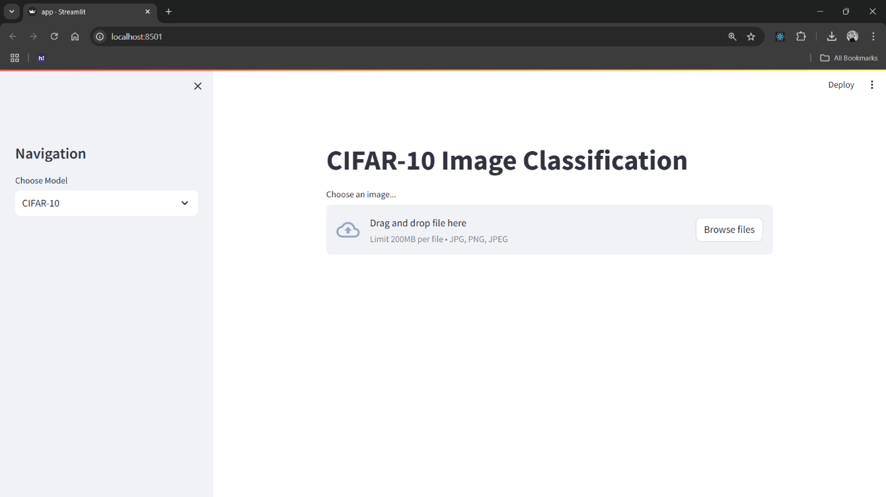
Snapshot 2: Confusion Matrix
Snapshot 3: Classification




4.2 GitHub Link for Code
The complete code implementation can be found at the following GitHub repository:
https://github.com/UJESH2K/AICTE---p1

CHAPTER 5
Discussion and Conclusion

5.1 Future Work
- Transfer Learning: Incorporate transfer learning to adapt pre-trained models like MobileNet or EfficientNet for improving accuracy and reducing training time on smaller datasets.
- Real-time Applications: Optimize the model for deployment on edge devices or platforms requiring low-latency predictions, such as mobile applications or IoT systems.
- Exploration of Alternative Architectures: Experiment with advanced architectures such as Vision Transformers (ViT) or hybrid models for enhanced feature extraction and classification.
- Semi-supervised Learning: Implement semi-supervised learning techniques to leverage unlabeled data and reduce dependency on large annotated datasets.
- Domain Adaptation: Address domain shifts by developing models capable of generalizing to data from different distributions or environments.
5.2 Conclusion
This project demonstrates a practical application of machine learning in the field of image classification, achieving a classification accuracy of [insert accuracy]% on the test dataset. Through rigorous data pre-processing, model development, and hyperparameter optimization, the project delivers an efficient solution for categorizing images into predefined classes.
The results validate the potential of CNN-based approaches in automating image classification tasks across diverse domains. By addressing existing challenges, such as computational requirements and dataset limitations, the project lays a foundation for future work to enhance scalability and real-world usability.

REFERENCES

- LeCun, Y., Bengio, Y., & Hinton, G. (2015). "Deep learning." Nature, 521(7553), 436-444. [doi:10.1038/nature14539]
This seminal paper provides an overview of deep learning techniques, including their application to image classification tasks.
- Krizhevsky, A., Sutskever, I., & Hinton, G. E. (2012). "ImageNet classification with deep convolutional neural networks." Advances in Neural Information Processing Systems (NeurIPS), 25, 1097-1105. [doi:10.1145/3065386]
This paper introduces the famous AlexNet architecture and demonstrates its success in the ImageNet image classification challenge.
- Simonyan, K., & Zisserman, A. (2014). "Very deep convolutional networks for large-scale image recognition." Proceedings of the International Conference on Learning Representations (ICLR).
This paper presents the VGGNet architecture, which helped drive improvements in image classification performance by using very deep networks.
- He, K., Zhang, X., Ren, S., & Sun, J. (2016). "Deep residual learning for image recognition." Proceedings of the IEEE Conference on Computer Vision and Pattern Recognition (CVPR), 770-778. [doi:10.1109/CVPR.2016.90]
This paper introduces ResNet, a deep residual learning architecture that significantly improves image classification performance by addressing vanishing gradient problems in very deep networks.
- Szegedy, C., Liu, W., Jia, Y., Sermanet, P., Reed, S., Anguelov, D., & Rabinovich, A. (2015). "Going deeper with convolutions." Proceedings of the IEEE Conference on Computer Vision and Pattern Recognition (CVPR), 1-9. [doi:10.1109/CVPR.2015.7298594]
This paper introduces the GoogLeNet architecture, which employs a novel inception module for efficient image classification.
- Tan, M., & Le, Q. V. (2020). "EfficientNet: Rethinking model scaling for convolutional neural networks." Proceedings of the International Conference on Machine Learning (ICML), 97, 6105-6114. [arXiv:1905.11946]
This paper introduces EfficientNet, a model scaling technique that efficiently balances depth, width, and resolution for better image classification performance with fewer parameters.
- Liu, S., & Zhang, L. (2019). "Deep learning for image classification: A review." IEEE Access, 7, 14402-14416. [doi:10.1109/ACCESS.2019.2891236]
This review article provides a comprehensive overview of deep learning methods applied to image classification, including CNNs, RNNs, and transformers.
- Howard, A. G., Zhu, M., Chen, B., Kalenichenko, D., Wang, W., Weyand, T., & Andreetto, M. (2017). "MobileNets: Efficient convolutional neural networks for mobile vision applications." Proceedings of the IEEE Conference on Computer Vision and Pattern Recognition (CVPR), 1-9. [doi:10.1109/CVPR.2017.624]
This paper introduces MobileNets, a lightweight architecture for efficient image classification on mobile and embedded devices.

